TimeLine Game Style Guide.

Overview   
  
This style guide will be used to show the art style throughout the project. Our interactive game is being used in Ipswich museum to attract children into an exhibition to teach them about what artefacts have been found around Ipswich. The interactive map will show the post codes of ip1, ip2, ip3 and ip4, this will give children the opportunity to search their home address to see what information they can find. On the map there will be a timeline at the bottom waiting to be filled with the correct information, to receive the information the children must interact with the characters hovering above each ip address. They will hold the information of what artefacts were found, what date they were found, and some information about the artefact’s history. Once the children have read the information and had a look around the exhibition they will then be able to drag the artefacts onto the timeline in the correct order. if the players get the order wrong they have the chance to go back to the exhibition to receive extra information or they can restart the game and try again.

The game is targeted at children, but it is also targeted at schools and families to increase their knowledge of Ipswich history.   
  
From studying our target audience, we explored different aesthetics that would attract children to the game. In an article online called ‘**sciencing**’ it says “*children tend to be attracted to the bright block colours of the colour wheel rather than pastels or muted blends. Primary colours (red, yellow and blue) and secondary colours (green, orange and purple) are more appealing than light shades of pink and beige or neutral shades of grey and brown. For this reason, the food and beverage industries, as well as the toy industry, have use bright colours to market children's products”,*It also says “*Colours have long been said to affect people's moods and can have a significant effect on developing children. Warmer colours like orange and yellow bring happiness and comfort. Red has been known to increase the heart rate and therefore increase alertness and the appetite, while cooler colours like blue and green tend to have a calming effect.”*  
With this information we will create characters and backgrounds suited to our audience, focusing on ‘reds,oranges,yellows’ for the characters, and ‘greens,blues,purples’ for the backgrounds.  
We want to create an exciting experience for the children, so by making the interactive characters cell shaded in a cartoon style, we feel we could retain their attention to the screen so each child has the ability to learn something new.   
The television show Horrible Histories attracts and holds children’s attention by using the same colourful sketched characters to tell historical stories in a humorous manor.

Mood Board  
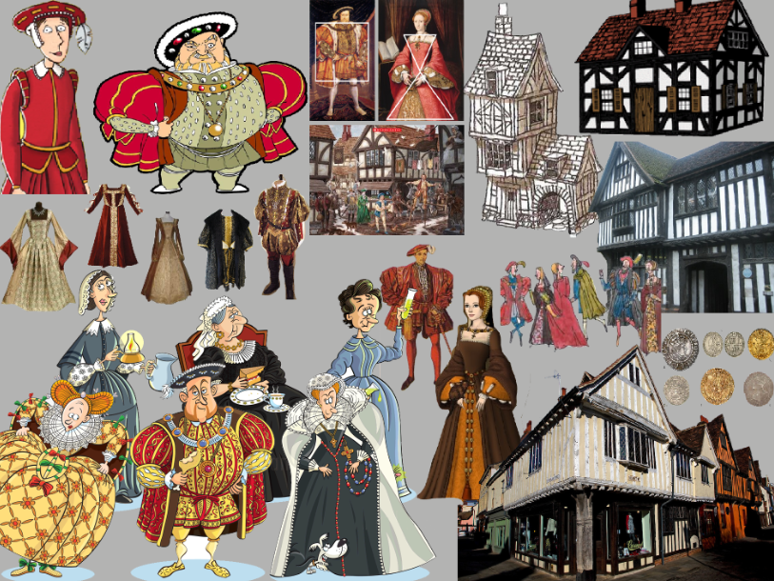  
In the mood board we collected images of Tudor and Victorian cartoon characters, these will be used for their shape and cartoon style. We have images of Tudor housing and buildings around Ipswich for inspiration, the buildings will be used for the backgrounds. There are images of the type of clothing worn in that era, these can be used when designing characters clothing.   
  
Colour Palette  
We shall make the characters contrast with the back ground by designing the characters with a warm palette and the background with a cool palette. By doing this we will improve the visual hierarchy, the children will look at the characters first instead of the background.

Going back to our previous study, it said about primary colours red, yellow and blue being used as they are more appealing, but they don’t particularly like browns, beige or grey. In the mood board there are items from the era that appear quite dull, which might bore the children, to prevent this happening the use of browns, beige and greys need to be kept to a minimum, only in small sections of the clothing.

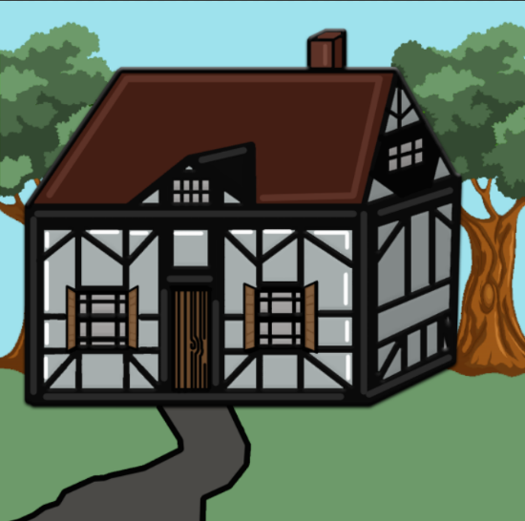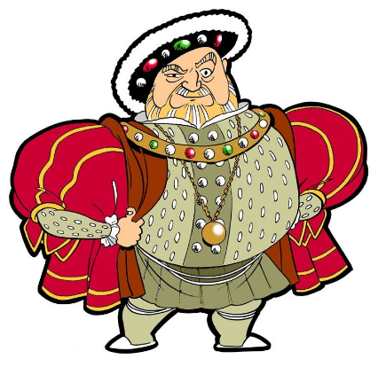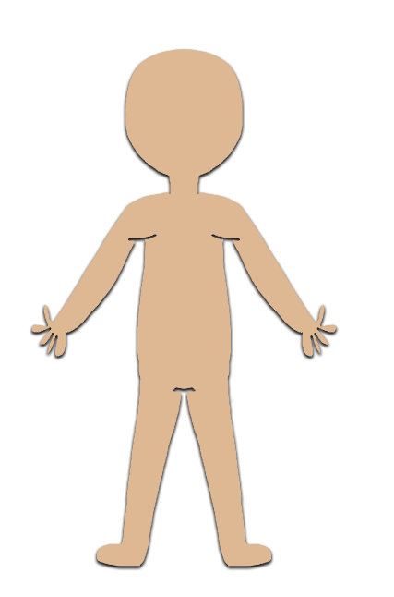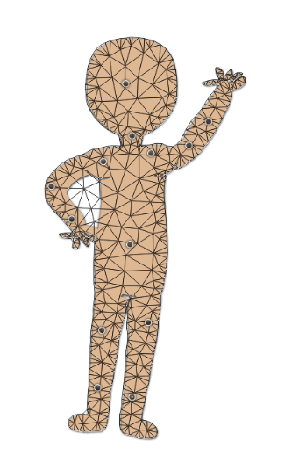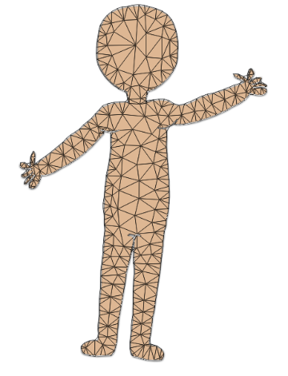Characters   
Each character will start off as a cartoon outline, but they must be facing forward so it is easier to animate. On the right there are some examples of how we could animate it in photoshop using puppet warp. It is a quick and effective way to get the characters moving.   
  
A black outline will be needed around the characters, so they don’t blend with the backgrounds. This will make them easy to see as they will be highlighted.  
  
There will be four characters’ overall, one for each IP address, each character will wear something different, relating to their artefact and the time frame, there are examples of the clothes worn in the Tudor period on the mood board, these can be used for inspiration. As well as this the character’s gender must be balanced with two females and two males, if we didn’t make it balanced it would look like we are only aiming the game at one gender, which we are not. We want a large audience to play this game, a mixture of males and females.   
  
The characters will change pose once the players click on them, this will then take them to the information tab with the artefact pictures. The poses could change from a standing position to a waving position to notify the player that they know they’re there to make them feel involved in the game.   
  
Background

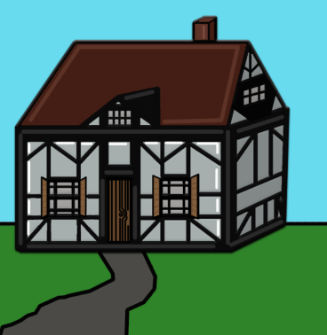To create the backgrounds, the designers need to relate the environment to the character’s artefacts / time frame. Once they have decided which background they want to do they can then research where the artefacts were found. In one case there may be a Tudor living in one of Ipswich’s old buildings, on the screen there will be a cartoon building in the background and the matching character in the foreground. Each artefact will be highlighted with an outer glow.   
  
The drawings on the right are examples of what the houses may look like, in the first drawing it is bright and childlike, however it does not fit our colour palette. Having bright colours in the background as well as the foreground will not help the visual hierarchy. On the right of the drawing stands a second house, but this time it has the colours from our colour palette. These colours are dull, but they will contrast well with the characters.

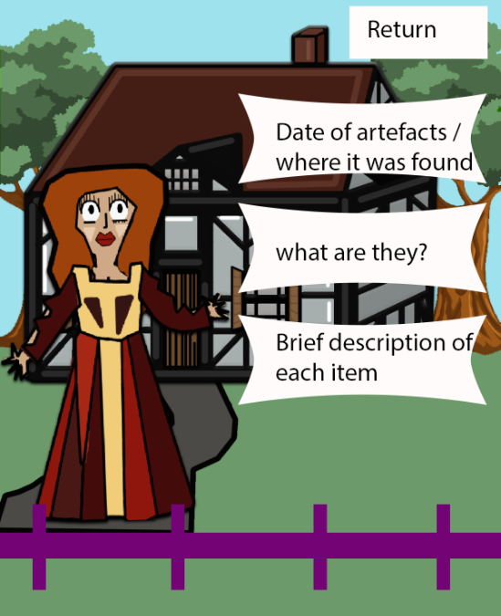Screen Mock-up   
  
This is not the final art work. This is an example of how each character will stand on one side waving at the players whilst giving out information on the artefacts found in that location. The eyes and arms will move every 5 seconds.  
  
The information boxes will fit in with the theme, they will not be white boxes.   
  
  
  
  
  
  
  
  
Visual Effects   
  
Once the player completes the time line, there will be a box that pops up saying ‘you win’. This box will be animated to pop out like a party popper. If the player doesn’t complete the time line and there’s a few errors, the errors will be highlighted giving them a second chance to finish it and a box will pop up saying ‘you lose but give it another try’, if the player gives up there is a return to beginning button for those who pick up after them.